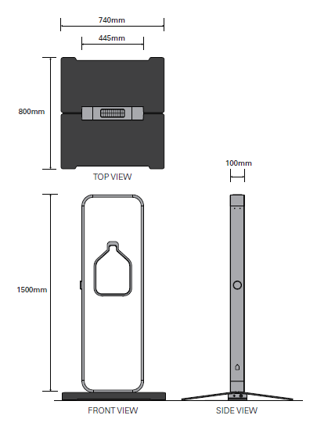
Thank you for choosing to use the Walpole CRC Water Refill Station for your next event. The water station is a great way to encourage people to refill water bottles, recycle better and reduce waste to landfill. Our water station is available to hire for community or private events within the local area.

A bond of $50 and a Hire Fee of $25/day must be paid on collection of the Water Refill Station.

Please complete and return this form via email to reception@walpole.org.au for confirmation of your booking or talk to our Manager at the CRC during opening hours.

Contact Details

Name: | Click or tap here to enter text.
Organisation:  (if applicable) | Click or tap here to enter text.
Phone: | Click or tap here to enter text.
Email: | Click or tap here to enter text.

Event Details

Event Name: | Click or tap here to enter text.
Start Date: | Click or tap to enter a date. | End Date: | Click or tap to enter a date.
Event Location: | Click or tap here to enter text.

Collection/Return Dates

Collection Date: | Click or tap to enter a date.
Return Date: | Click or tap to enter a date.

Bond Paid ($50) ☐ yes ☐ no Hire Fee Paid ($25/day) ☐ yes ☐ no
Terms & Conditions

To Hire the Water Refill Station please read the terms & conditions, check the box to agree and sign below:
☐ This equipment is being borrowed for a community/private event within the local area.
☐ Collection and return of equipment is the responsibility of the hiring organisation/hirer. Please allow 30 minutes to run through set/pack up instructions when arranging suitable pick-up and drop-off times. Walpole CRC office hours are Monday-Friday, 9am-4pm.
☐ A bond of $50 will be paid on collection of the equipment, along with a hire fee of $25 per day (including GST). The bond will be refunded on return of the equipment, once an inspection has been conducted and the equipment is deemed to be in the same condition as it was collected.
☐ Proper care of equipment will be taken during transportation, set-up and pack-down.
☐ The equipment will not be left unsupervised or left overnight without appropriate security or shelter.
☐ The cost of any damage to equipment or lost parts while in your possession will be covered by the hiring organisation/hirer.
☐ Water station signed in and out on collection and return from the Walpole CRC office at:
Walpole Community Resource Centre, 24 Latham Avenue, Walpole, 6398
☐ There is access to a mains water tap at event location to hook water station in to.
☐ The mains water tap has a thread to attach the hose to (i.e. it is not a self-closing tap).
☐ The Water Station will not be set-up near live exposed electrical connections/wiring or in high wind areas.
☐ The Water Station and hoses will not be set-up in direct sunlight as water will become hot.
☐ Actions will be taken to ensure water hoses that pass over traffic areas are not a trip hazard (e.g. covered, signage)
☐ Water will be flushed through fountains before use and at the beginning of each day.
☐ Water station, fittings, hoses and instructions will be emptied of water, cleaned and dried before being returned to Walpole CRC.

We encourage you to:
☐ Promote the Water Refill Station prior to the event, so attendees are aware to bring a reusable water bottle.
☐ Use signage provided at the event for an easy to find water station.
☐ Include the water station on the event map if applicable.
☐ Announce the availability of the water station and encourage use at the event.

I have read and agree to the terms and conditions:
Name | Date
Click or tap here to enter text. | Click or tap to enter a date.

Equipment Checklist for Collection & Return

This part of the form is to be completed by a CRC team member with you upon collection and return of your equipment.

Please Check boxes | Check Out | Check  In | Notes (if any)
Water Bottle Refill Unit  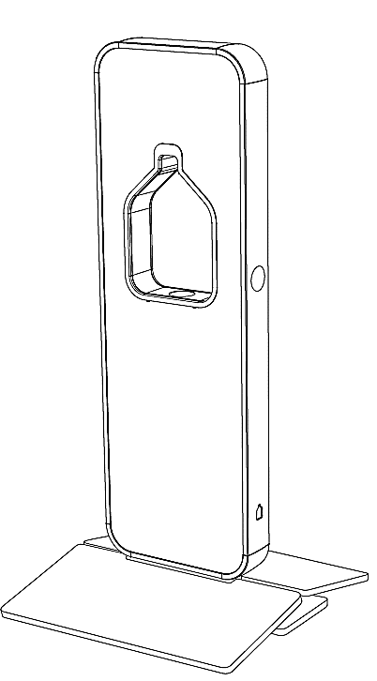 | ☐ | ☐ | Click or tap here to enter text.
Tap Adaptor short (screwed into long) | ☐ | ☐ | Click or tap here to enter text.
Water Hose (long blue hose 1) | ☐ | ☐ | Click or tap here to enter text.
Drain Hose (long blue hose 2) | ☐ | ☐ | Click or tap here to enter text.
2x Base Plates | ☐ | ☐ | Click or tap here to enter text.
Allen Key | ☐ | ☐ | Click or tap here to enter text.
Set-up and usage instructions pack | ☐ | ☐ | Click or tap here to enter text.
Signage | ☐ | ☐ | Click or tap here to enter text.
4x spare AA Batteries | ☐ | ☐ | Click or tap here to enter text.

Privacy Policy
BBCRC is committed to protecting the privacy of personal information which the organisation collects, holds and administers. The information is collected to: provide BBCRC products or services, and carry out internal administrative operations. Please read our Confidentiality and Privacy Policy for more information.

 | CRC Staff Signature | Date | Contact Signature | Date
Collection
Return

